**Chapter 17 LARRY AND KEN**

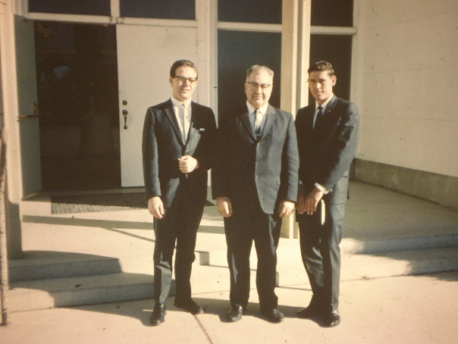

**Ken was called to be the 1st counselor to Bishop Moulton of the Mount Fort Ward**, **Larry was called to be the 2nd counselor. Ken was only 24 at the time. He enjoyed working in this Bishopric and he grew to love Bishop Moulton**.

**About that time Larry asked Ken to go into partnership with him in his construction company. Ken had been working some for Larry and Larry could see Ken's potential and by this time, Ken was dissatisfied with his job at Commercial Security Bank**. Ken was really good as a computer operator, programmer and now he was a supervisor, but the shift work was getting to him, plus always being on call. He would be called in the middle of the night and if he couldn't solve the problem over the phone, he would have to get dressed and go into work. They had conversions where he would have to work straight through until the conversion was done. One time it lasted for 36 hours. By this time, Ken's head was pulled over to his shoulder and he had to get several chiropractic treatments to get it straightened out. It was stressful and he felt he would like to get out of the office and work with his hands in the fresh air. He talked to his Uncle Irven who was a building contractor all his life. He counseled Ken not to do it as building is so up and down and also so hard. He didn't heed Uncle Irven's advice..

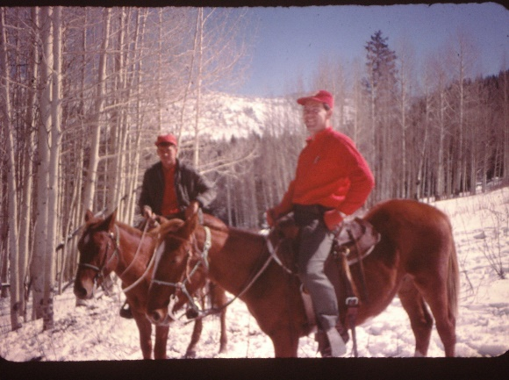 The bank tried to discourage him from quitting in every way they could. They told him he would lose his shirt if he did because interest rates were going up and also prices on materials. We thought they were just saying this as they hated to lose a good man. This they did, but they also felt he would be making a big mistake. The main reason I hated to see Ken go into this field was because he had had two previous sun strokes. One when he was a boy fishing and the other while in basic training for the Air Force in Lackland, Texas. The doctors have told him that if he had another he couldn’t possible live through it. That it was practically a miracle that he had lived through the second one and especially without having any brain damage. For this reason, I felt Ken might have another if he was out in the sun all day every day. Ken felt with being able to cool down at night he would be okay and if he felt he was getting too much sun he would try to work indoors and he’d take salt pills. The first year he enjoyed working with Larry and loved this work and it seemed to be going well**. They enjoyed working together and when Ken didn’t get paid for one job, the guy asked him if he would take a couple of horses for the work. Larry & Ken had broke some horses and Larry had horses, so this was fun**. We had lots of good times with the horses. One trip was a pack-in-trip with Larry & Tammy, Bob & Pauline, John & Linda & Ken & I. We were living in Clearfield at the time. It was so beautiful there and we all had a great time. We almost had a terrible accident coming down the mountain. Ken was driving the big truck with the horses in it. Bob & Pauline were riding with us. The horse started to slip and it threw the truck off the small windy road, and I am sure it was the hand of the Lord who stopped the truck as the truck front tires were resting on a small tree and only the back tires were on the road. Ken told Bob, Pauline & I to carefully get out of the truck. He stayed in with his foot on the brake. We climbed out and Larry had a chain, so he pulled the truck back on the road with his truck. I’m sure the Lord made that possible also, as the one Ken was driving was much bigger and it was a wonder that the horses didn’t keep sliping and sliding and the four of us could have easily met our death that day. Pauline was so scared that she wouldn’t get back in the truck. She said she would walk. We finally convinced her that she couldn’t walk that far, so she got in.

The second year, with Larry & Ken’s business, didn’t work so well. With Ken and Larry working together all day and doing Bishopric work just about every night, they were with each other more than they were with us, their wives. They began to get on each other’s nerves, and problems began to arise. Also interest and lumber prices did go up. They would bid on jobs and before they were through with it, with the rising costs, they would lose money. Also, Larry didn’t bid them high enough because he was too good hearted and wanted to help the people out as much as he could. This didn’t work out either because most of the people he did this for would turn around and cut his throat - so to speak. It got worse and worse until finally after two years they had to drop the business and go to work for another contractor, Perk Peterson. They lost about $12,000. They divided this amount. We owed $3,000 to Moyes Glass and Paint Company and $3,000 to Wheelright Lumber Company. One of the main problems was they had an accountant who was supposed to keep them advised on how their finances were going, but he didn’t until he told them they were $12,000 in debt. They should have checked more with him, so it was partly their fault too.

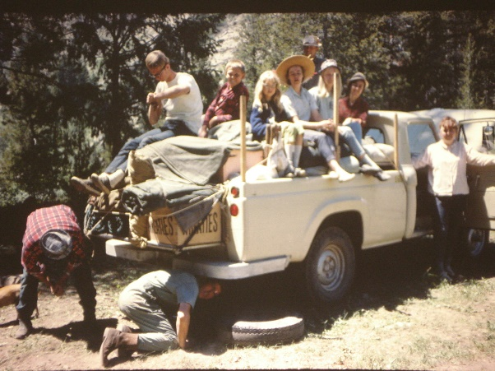

**Jennie’s Lake in Wyoming** – When the children were young, in fact we only had Sandi and maybe Shellie at that time, and Larry & Tammy lived in our ward, we would go with them to Jennie’s Lake in Wyoming to camp and fish. It was a great place to go and we loved being with our good friends. We went there several times. One time we invited the families from our “Ward’sYoung Married Group” and that was fun too. Sometimes we would get a babysitter for our daughters and the four of us would climb in the cab of their truck and go four wheeling up in the mountains. It was always fun.

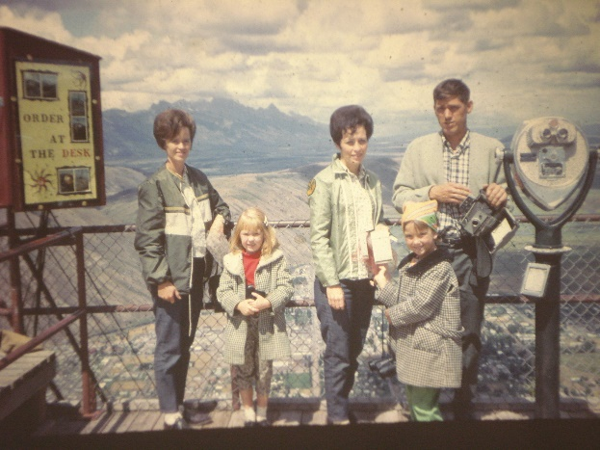

The first summer, when Ken & Larry were working together, the four of us took our girls, Sandi & Lori, who were the same age and became good friends, **and went to Yellowstone Park together**. Larry & Tammy had bought a camp trailer. We had a great time together. Tammy & I have always been close, even when our husbands were having problems, we didn't. We always felt we were as close as sisters. The good part was that we didn't fight as some sisters do. We even dressed alike sometimes and people thought we were sisters. Many times, while our husbands were working, her and I would get together and make crafts, work on scrapbooks or picture albums, make Christmas candy together, etc., etc.

Ken didn’t like working for Perk Petersen because he couldn’t trust him. He would say one thing and do another. We had a hard time getting our pay check and when we did, it usually bounced. Perk didn’t keep track of his money, and would write out checks and didn’t know there wasn’t money to clear them. This happened time after time until Ken finally quit and went to work for Modular Construction Company at Free Port there in Clearfield.

At this time Larry and Tammy had purchased some land in Liberty (up above the dam at Ogden Canyon) to build their home on and have some animals. We figured we would trade our equity on our home in Ogden for some land in Eden (close to Liberty). Ken and Larry figured to help each other build their homes. We talked with the man about the land and had papers drawn up. We moved out to Clearfield to Uncle Dale and Aunt Esther’s old home to rent until we figured we could move into our new home in Eden. After we were moved this man figured he had us over a barrow with us out of our home so he backed out of the agreement - didn’t want to give us what we had asked out of our home on the land. He also wanted us to pay closing costs, etc. We couldn’t afford to do this. Like dumb bells, we hadn’t had him sign a contract. We talked to a lawyer and he advised us to just let it drop and sell our home to someone else. We tried to, but were having difficulty so decided to rent it for a while. That was a big mistake as the couple who rented it just they just had a couple of children and no pets. Well, soon after they moved in, other family members moved in with them and they had several pets. They didn’t take care of the house or yard and, in fact, wrecked the place. It wasn’t long until the neighbors called complaining about these people. They didn’t pay the rent either, so we tried to evict them, but it wasn’t that easy as they had small children. We took them to court, but they didn’t show up, so the judge awarded the case to us. Ken asked him what that meant and he said we had the right to collect it from them. Wow! That wasn’t helpful. Finally, the gas company called us to tell us that the gas bill hadn’t been paid and they were going to shut off the gas. The power company said the same, and we told them both to go ahead and shut off the utilities. It wasn’t long until those people moved out. But, we sure had a mess to clean up and replace carpet, screen door, repaint, redo the lawns, etc. We even found a partially dead cat in a sack in the garbage. We heard it moving around and thought it might be a rat. When Ken took it outside and shook it out, he was mad. They had kicked the cat, broke it’s back and put it in the sack to die. Wish we could have reported them to the humane society.